Save the Date: Natural Hazards Summer Institute
Title 1 High School Teachers

WHEN: Monday, June 03 – Friday, June 07, 2024

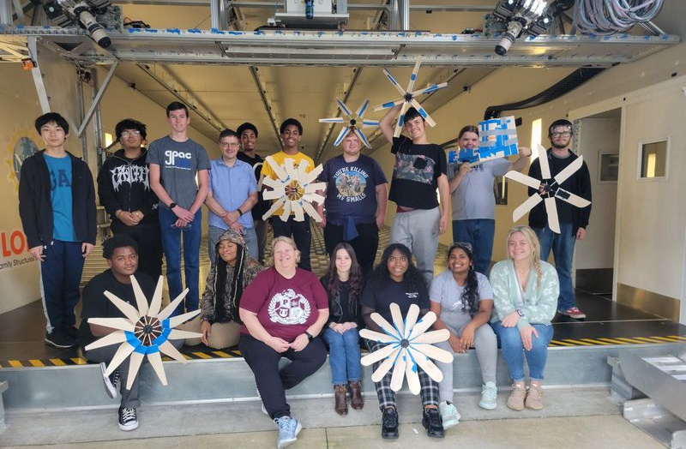
WHO:
High School Teachers from Title 1 Schools in the State of
Florida Public School System.
WHAT:
A week-long summer professional development sponsored by the National Science Foundation (NSF) held at the University of Florida. This PD will include a curriculum on learner-centered teaching, design thinking, and engineering design. Teachers will tour the NSF-funded natural hazard experimental facility and develop a project-based learning activity for their classrooms.

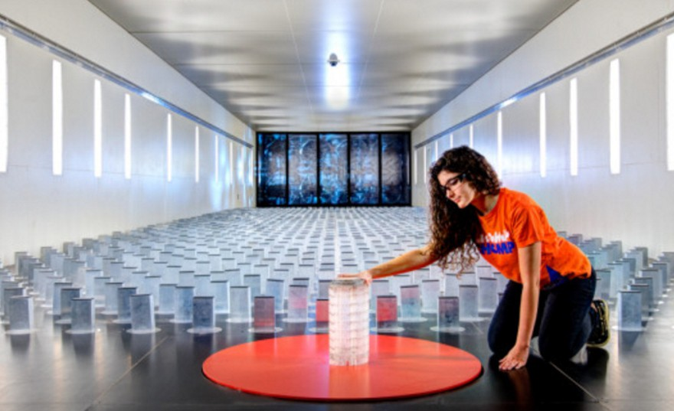
WHERE: The University of Florida, Gainesville, Florida
Condensed Agenda
- Monday – Welcome & Campus Tour
• Tuesday – Engineering Design & Design Thinking
- Wednesday – Course Mapping
- Thursday – Experiential Learning
- Friday – Project Showcase

Each day will include hands-on activities, facilities tours, and presentations from UF engineering faculty, staff, and graduate students. Participants will also receive a stipend of $500, in addition to travel, hotel accommodations, and per diem.
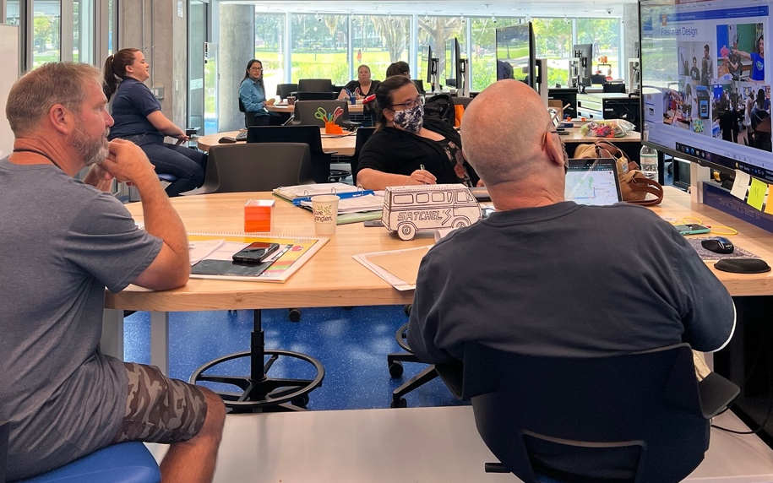

For Questions, Please Contact:

Jeremy A. Magruder Waisome, Ph.D.
Thomas O. Hunter Rising Star Assistant Professor
University of Florida
jwaisome@eng.ufl.edu
To Learn More About UF NHERI:

Visit https://ufl.designsafe-ci.org/outreach

Our Facilities: The UF NHERI Experimental Facility is
located at Powell Family Structures & Material Lab
Address: 2070 NE Waldo Rd., Gainesville, FL 32609

